on-line TUTORIAL
Statistical Tools for Managers

Discussion Questions
1. A probability distribution is a statement of a probability function
which assigns all the probabilities associated with a random variable.
A discrete probability distribution is a distribution of discrete random variables (i.e., random variable with a limited set of values.)
A continuous probability distribution is concerned with a random variable having an infinite set of values.
2. The expected value is the average of the distribution and is computed for a discrete distribution using the following formula:
E(X) = Σ [X × P(X)]
3. The variance is a measure of the dispersion of the distribution.
The variance of a discrete probability distribution is given by the following formula:
V = Σ [X – E(X)]2 × P(X)
4. Examples of business processes which might be described by a normal distribution could include sales of a product, project completion time, average weight of a product, and product demand during lead time or order time.
End-of-Tutorial Problems
T1.1 | Number of Loaves | Probability | Expected Loaves
 | 0 | 0.05 | 0.00
 | 1 | 0.15 | 0.15
 | 2 | 0.20 | 0.40
 | 3 | 0.25 | 0.75
 | 4 | 0.20 | 0.80
 | 5 | 0.15 | 0.75
 |  | Σp(x_{i}) = 1.00 | Σ n_{i} × p(x_{i}) = 2.85
The average (expected value) number of loaves is given by:
nave = Σni × pi
The store will sell, on average, 2.85 loaves of bread.

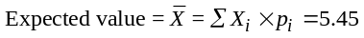
T1.2 | x | P_{X} | x_{i} × p(x_{i}) | x_{i} – E(x) | (x_{i} – E(x))² | (x_{i} – E(x))² × p(x_{i})
 | 1 | 0.05 | 0.05 | –4.45 | 19.8 | 0.99
 | 2 | 0.05 | 0.10 | –3.45 | 11.9 | 0.60
 | 3 | 0.10 | 0.30 | –2.45 | 6.0 | 0.60
 | 4 | 0.10 | 0.40 | –1.45 | 2.1 | 0.21
 | 5 | 0.15 | 0.75 | –0.45 | 0.2 | 0.03
 | 6 | 0.15 | 0.90 | 0.62 | 0.3 | 0.05
 | 7 | 0.25 | 1.75 | 1.52 | 2.4 | 0.60
 | 8 | 0.15 | 1.20 | 2.52 | 6.5 | 0.98
 |  |  | Σ = 5.45 |  |  | Σ = 4.06

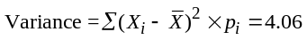
T1.3 Here: x = 280, μ = 250, σ = 25. Given:
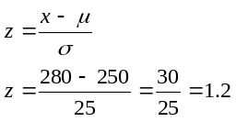
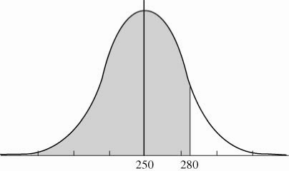
From the table in Appendix I, we see that the area under the
curve corresponding to a z of 1.2 is 0.8849, i.e., P(z ≤ 1.2) =
0.8849.
Therefore, the probability that the sales will be less than or equal to 280 boats is 0.8849.
T1.4 (a) The probability that sales will be greater than or equal to 265 boats is found as follows:
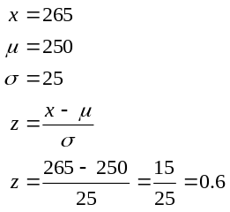
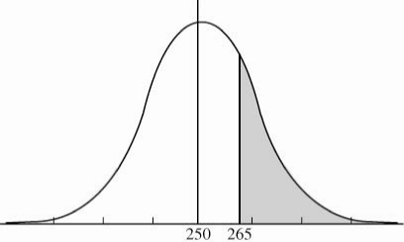
From the table in Appendix I, we see that the area
under the curve corresponding to a z of 0.6 is 0.7257, i.e., P(z ≤ 0.6) = 0.7257. We, however, need the proba-
bility of selling more than 265 boats, i.e., P(z > 0.6).
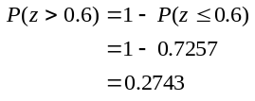
Therefore, the probability of selling more than 265 boats is 0.2743.
(b) The probability of selling less than or equal to 250 boats is found as follows:
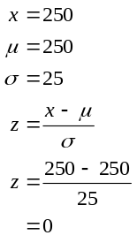
The area of concern is that lying to the left of μ. That area is 0.5. Therefore, the probability of selling 250 or fewer boats is 0.5.
T1.5 The probability of the shaft diameter laying between 0.55 and 0.65 inches is found as follows:
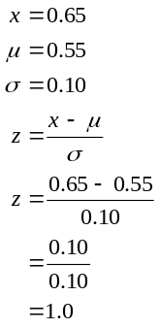
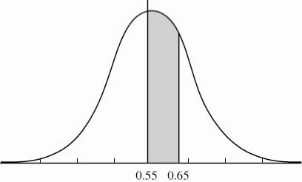
From the table in Appendix I, we see that the area under the curve corresponding to a z of 1.0 is 0.8413, i.e.,
P(z ≤ 1.0) = 0.8413.
We are looking for P(0.55 ≤ x ≤ 0.65):
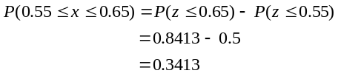
[Remember: μ = 0.55 and P(x ≤ μ) or P(z ≤ 0) = 0.5]
Therefore, the probability that the diameter of a shaft selected at random will be between 0.55 and 0.65 inches is 0.3413.
T1.6 (a) The probability of the shaft diameter exceeding 0.65 is found as follows:
From Problem T1.5, we found that 0.65 corresponds to z = 1, and that the area to the left of z = 1 was 0.8413.
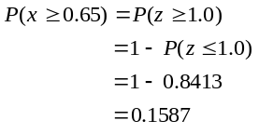
Therefore, the probability that the diameter of a shaft selected at random will be greater than or equal to 0.65 inches is 0.1587.
(b) The probability that the shaft diameter will be between 0.53 and 0.59 inches is found as follows:
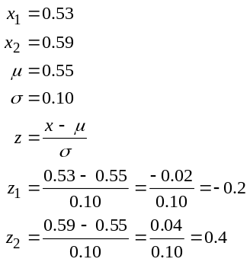
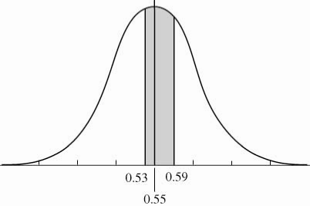
Because the table in Appendix I handles only positive z values, we need to calculate the probability of the shaft size being greater than 0.55 + 0.2 = 0.57 inches. This is determined by finding the area to the left of x = 0.57 that is, to the left of 0.2σ[P(x ≤ 0.57) = P(z ≤ 0.2)]. From the table, we see that this area is 0.5793. The area to the right of 0.2σ is then:
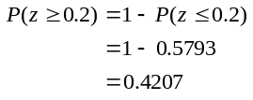
The area to the left of x = 0.53 is also 0.4207 because the curve is symmetrical. The area to the left of
0.4σ[P(z ≤ 0.4)] is 0.6554. The area between x1 and x2 is therefore:
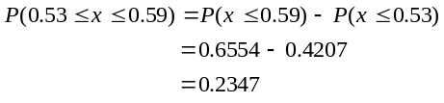
Therefore, the probability that the diameter of a shaft will be between 0.53 and 0.57 inches is 0.2347.
(c) The probability that the shaft size will be less than or equal to 0.45 inches is found as follows:
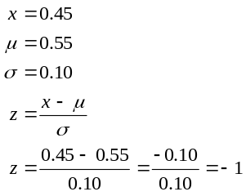
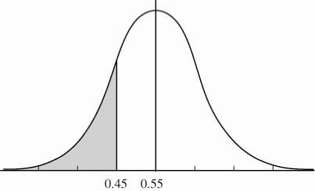
Thus, we need to find the area to the left of 1σ, i.e.,
P(z ≤ 1) Because the table in Appendix I handles only positive values of z, we need to determine the area to the right of z = 1. This area is obtained by finding the probability:
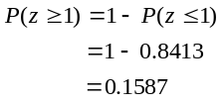
(Where 0.8413 = P(z ≤ 1) is obtained from the table in Appendix I.)
Thus, the probability that the shaft has a diameter less than or equal to 0.45 inches is 0.1587.
T1.7 (a) The probability that the oven temperature exceeds 475° is found as follows:
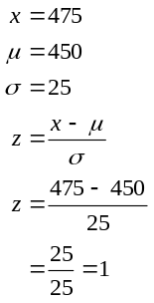
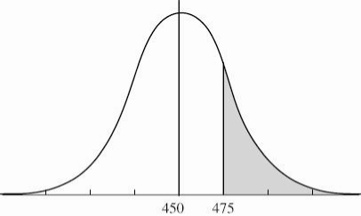
From the table in Appendix I, the area to the left of
z = 1[P(x ≤ 475)] is given as 0.8413. The area to the right of z = 1[P(x ≤ 475)] is therefore given by:
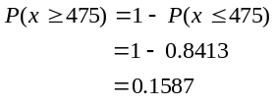
Thus, the probability of the oven temperature reaching or exceeding 475° is 0.1587.
(b) The probability that the oven temperature lies between 460° and 470° is found as follows:
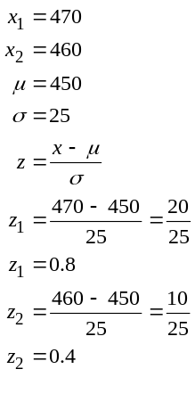
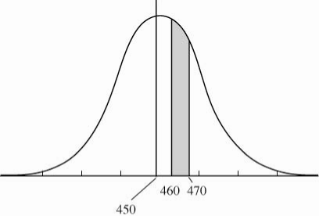
Therefore:
From the table in Appendix I:
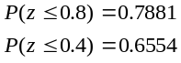
and
Thus, the probability that the oven temperature will be between 460° and 470° is 0.1327.
T1.8 (a) The probability that sales will be greater than 5,500 oranges is found as follows:
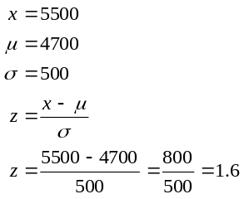
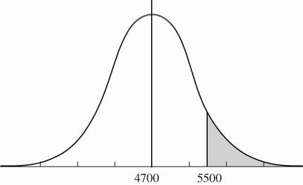
From the table in Appendix I, P(z ≤ 1.6) = 0.9452.
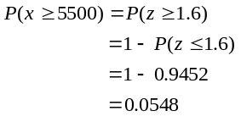
Therefore, the probability of selling at least 5500
oranges is 0.0548.
(b) The probability that sales will be greater than 4500
oranges is found as follows:
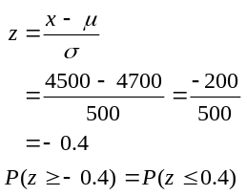
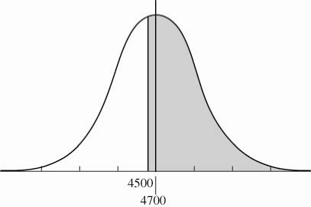
From the table in Appendix I, P(z ≤ 0.4) = 0.6554
Therefore, the probability that sales will be at least
4500 is 0.6554.
(c) The probability that sales will be less than 4900
oranges is found as follows:
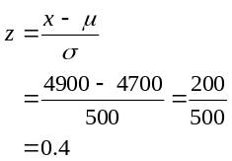
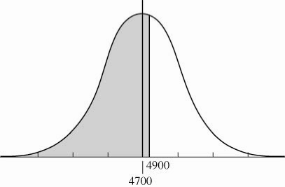
From the table in Appendix I:
P(z ≤ 0.4) = 0.6554.
Therefore, the probability that sales will be less than 4900 oranges is 0.6554. (Note that the answer to this question is the same as to question T1.8b—the normal distribution is symmetrical.)
(d) The probability that sales will be less than 4300 oranges
is found as follows:
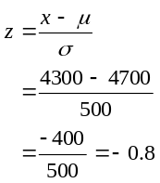
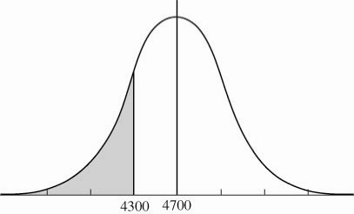
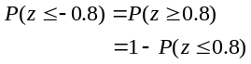
From the Table in Appendix I, P(z ≤ 0.8) = 0.7881
Therefore:
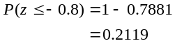
Thus, the probability of selling 4300 or fewer oranges is 0.2119.
T1.9 The probability that sales will be 81,000 or fewer units is found as follows
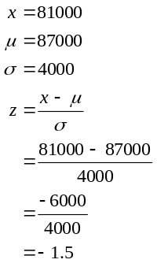
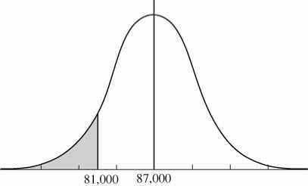
From the table in Appendix I, P(z ≤ 1.5) = 0.9332.
Therefore,
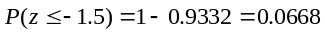
Thus, the probability that sales will be less than or equal to 81,000 packages is 0.0668.

